Main

Email footers of Team Adaptig

Finn Kraemer  Project Manager      finn@adaptig.com  +49 152 295 63398 | 

Jan-Eric Kloth  Co-Founder   jan-eric@adaptig.com   +852 98609468 | 

Footer Size Standard:
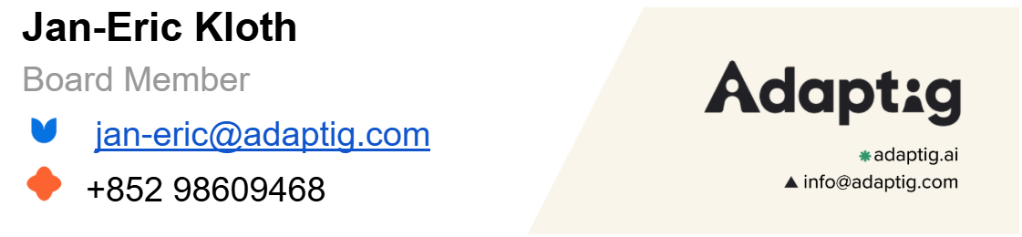

stuff
https://www.linkedin.com/in/finn-kraemer-3a8b2a192/
https://x.com/finn_kraemer

 | Finn Kraemer  Project Manager   finn@adaptig.com   +49 152 295 63398  

 | Finn Kraemer  Project Manager   finn@adaptig.com   +49 152 295 63398  

Finn Kraemer  Project Manager   finn@adaptig.com   +49 152 295 63398 | 

Finn Kraemer  Project Manager   finn@adaptig.com   +49 152 295 63398 | 

Finn Kraemer  Project Manager   finn@adaptig.com   +49 152 295 63398 |     

-

